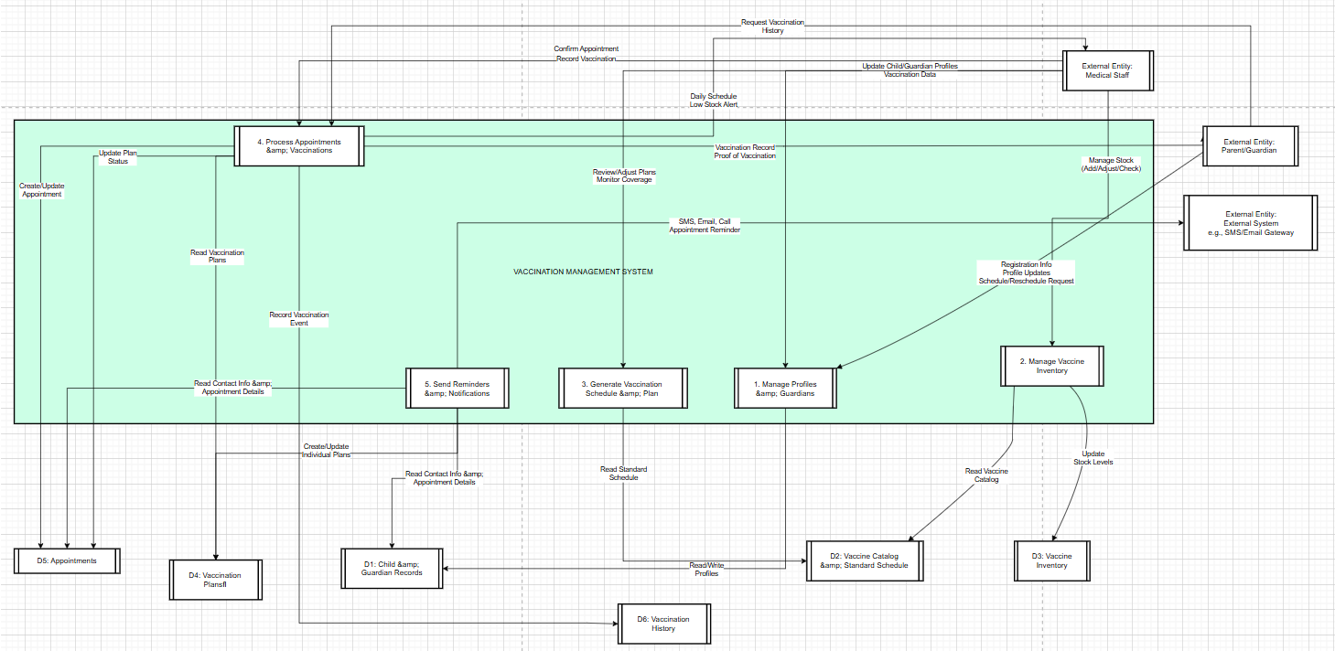

Explanation of DFD Level 0 Components:
1. External Entities:
- Parent/Guardian: Provides information, registers children, schedules appointments, and receives results and reminders.
- Medical Staff: Interacts directly with all system functions to operate the vaccination clinic.
- External System: Represents communication channels (SMS Gateway, Email Server) used by the system to send notifications.
2. Main Processes:
- 1. Manage Profiles & Guardians: Handles the registration and maintenance of all child and guardian information.
- 2. Manage Vaccine Inventory: Tracks vaccine stock levels, expiry dates, and batch information.
- 3. Generate Vaccination Schedule & Plan: Automatically creates personalized vaccination schedules for each child based on the standard schedule and date of birth.
- 4. Process Appointments & Vaccinations: Manages appointment booking, records vaccination outcomes, and updates the vaccination history.
- 5. Send Reminders & Notifications: Automatically generates and sends appointment reminders to parents/guardians.
3. Data Stores:
- D1: Stores core information from CHILD, GUARDIAN.
- D2: Stores reference information from VACCINE, STANDARD_SCHEDULE.
- D3: Stores the current status of VACCINE_BATCH.
- D4: Stores the specific vaccination plan for each child (CHILD_VACCINE_PLAN).
- D5: Stores appointment data (APPOINTMENT).
- D6: Stores the complete vaccination history (VACCINATION_RECORD), serving as the official record.

